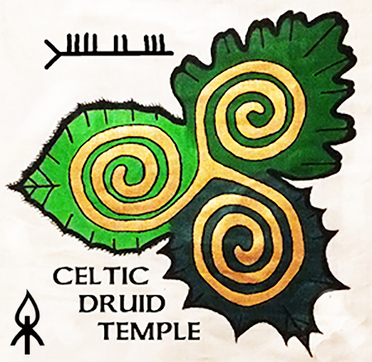

Executive Summary of the report titled
STOPPING THE WICCAN BURNING CULT

This report outlines the vandalism and hate crime committed on the 31st October 2018 on The Hill of Tlachtga by a group now called the 'wiccan burning cult'.
The crime had many elements, in the report I detail the crime itself and the resulting harm.
1. The burning of an ancient sun wheel symbol.
2. Criminal damage to a national monument by burning and hole digging.
3. Tax payers money financed this criminal act through Meath County Council.

The effects of their hate crime are multiple:

- The Temple of Tlachtga was physically damaged
- A 35 year local tradition was displaced causing deep hurt to many locals.
- A 16 year pilgrimage by Celtic Druid Temple was interrupted.
- Hatred was incited.
- This organised group are trying to claim a right to conduct burning of Pagan symbols on ancient national monuments as an indigenous tradition.

The 'wiccan burning cult' who make claim to indigenous rights are from the following various groups: OBOD, Fellowship of Isis, the Tweedies and individuals who are declared initiates of Wicca. The burning of Tlachtga was led by Gemma McGowan, a wiccan. I detail the history of each group and the individuals involved in this crime. I have collectively called them the 'wiccan burning cult' and this report destroys all claims they have made on indigenous rights in Ireland.

What is happening is incremental cultural misappropriation. Their cult has over 200 members and the active leaders are named here: Gemma McGowan, Karen Ward, Patsy Preston, retired Cllr Deirdre Wadding and John Cantwell. In October 2018 they were financed by Cllr. David Gilroy of Meath County Council / Meath Tourism. I do not attack these people. I am exposing what they did so they will not do it again. It is my intention that no minister or county councillor or tourism chief will never again grant aid Gilroy's ‘wiccan burning cult’.

I close the report by calling on all concerned people to say no to criminal damage to our national monuments by reporting all acts of criminal damage to An Garda Síochána and I call on all concerned people to join us on Tara for this Summer Solstice from Friday through to Sunday and become a ‘Protector of Tara’. By extension this means we will be part of a 32 county team that protects all of the ancient sacred temples in Ireland.

Full Report 09/04/2019

STOPPING THE WICCAN BURNING CULT

On the 31st of October 2018 near Athboy in Co Meath an ancient monument in formal guardianship by the state suffered deliberate criminal damage from fire and digging. This disgraceful “theatrical event” organised by Cllr Gilroy was given tax-payers money by Minister Shane Ross. The monument is Teampall Tlachtga, officially known as Hill of Ward Earthworks Wardstown Meath National Monument Number 150 RMP NUMBER ME030-00. Kells Gardaí are pursuing a criminal investigation listed within the Pulse System.

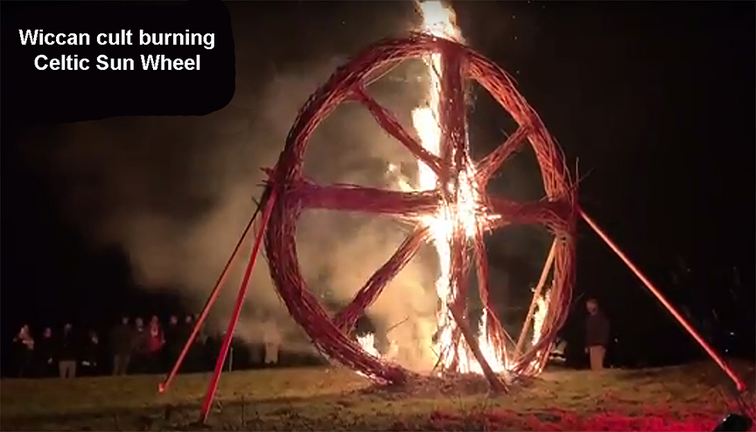

The burning of an ancient Irish sacred symbol in the form of a Sun Wheel made of wicker soaked in paraffin on the ground inside Temple Tlacthga was a pre-meditated 'hate crime' against the 'Friends of Tlachtga©' group and against the annual Celtic New Year Pilgrimage of the Celtic Druid Temple and against the Celtic Goddess Tlachtga and her temple. This burning contravenes Irish Law in many ways with fines up to €10,000,000 / 5 years in jail – see Notes 1 and 2 below.

An Athboy native has for over 35 years been steadily re-introducing the local population to the importance of Tlachtga. The 'Friends of Tlachtga©' local group are the founders and organisers of the Samhain Festival of Fire© and Torchlight Procession which annually took place in Athboy from 1999 to 2017. Every year the insurance for this popular local’s festival was paid out of one man's pocket. Attendance at these gatherings was always free of charge. The grass cutting, safety lighting, off-ground fire-box and snacks for the local children were always organised by the local people as this is their native indigenous tradition as a community. The 'Friends of Tlachtga©' are very concerned about the taxpayer funding the fire damage and the hole digging inside the temple and are also shocked at the hate crime of the 'wiccan burning cult' on halloween '18. What hurt them most, as local people who revived the Tlachtga Pilgrimage, was that they were pushed off Tlachtga by Cllr Gilroy and his ‘wiccan burning cult’ to facilitate an insulting disneyesque tourist event which Gilroy loudly claims that this “is actually what the public wanted”.

The 'Friends of Tlachtga©' fb pg 11 Nov 2018 says “with regard to the spirituality of the event, it was confirmed to us on the night by Cllr Gilroy that the event was never meant to have any spiritual content”. According to Cllr Gilroy, “the event was only ever meant to be theatrical as this is actually what the public wanted. We would have felt it more appropriate to see a lot more community involvement from the locality with such a large input of public funding. Schools and community groups no doubt would have loved to have been part of something that could have been as special as in years past and was being supported by the taxpayers funds.”

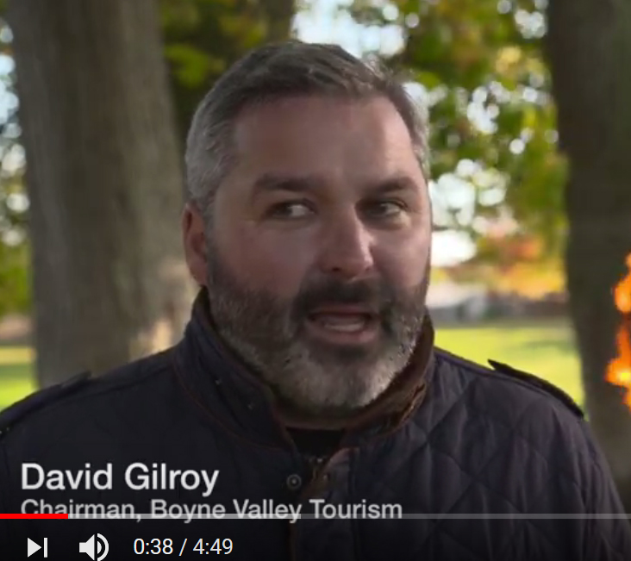

Exactly how much funding is unknown except for the €1500 from Minister Ross confirmed to me by email from his dept. But how can Gilroy so callously give out to the locals whose pilgrimage he displaced? The 'Friends of Tlachtga©' counted only 280+ participants at Gilroy’s temple burning on the 31st of Oct 2018, compared to their pilgrimage in 2017 that had 3,500+ attending. After Tlachtga '17, the local pilgrimage had become so popular that the 'Friends of Tlachtga©' decided to ask the County Council for support. They got Gilroy. As Meath tourism chief Gilroy only saw commercial opportunity. He totally dismissed and displaced a 35 year-old local tradition to suit his own agenda because he had full control of the grant aid.

The locals that Cllr Gilroy had excluded were not asked for their opinion or involvement in his theatrical event except for the token 3 minute speaking slot insultingly offered by Cllr Gilroy to 'Keeper of the Hill' Joe Conlon. As an honourable man, Joe refused to be the 'token local' speaker perhaps fearing it would be seen as supporting unrestrained theatrical commercialisation of our heritage. But when Cllr Gilroy said he “felt it more appropriate to see a lot more community involvement from the locality with such a large input of public funding” his doublespeak translates to 'very few of those attending were locals and the Keeper of the Hill was not there either'.

Cllr Gilroy had quietly pushed the “Samhain Festival of Fire© and Torchlight Procession” off Tlachtga to facilitate his commercial tourism plan. After 2017, the locals had to suspend their annual pilgrimage because it was getting way too big at over 3500 people. The council was asked for help / support etc., but their reaction through Gilroy was to displace the indigenous practice of the community with gaudy glamour and hate crimes burning sacred symbols and causing damage to the ancient temple with ground burning and the digging of numerous holes. When Gilroy said that his event was “never meant to have any spiritual content” he declared his plan to destroy the spiritual value of the “Samhain Festival of Fire© and Torchlight Procession” to the locals. When he says “the event was only ever meant to be theatrical as this is actually what the public wanted” he is lying as he knew it was not what the locals wanted – the locals had told him and Meath Co Co exactly what they wanted. Gilroy's “large input of public funding” was used without consultation with the locals i.e. the stakeholders, the people who brought all age groups of all faiths to the sacred site. When Gilroy says his event “could have been as special as in years past” he tells us that his event was not special, that he failed Tlachtga, that he insulted the locals, that he wasted taxpayers money on his attempt to convert a local pilgrimage celebration of our ancient heritage into a sterile commercial tourist event. Gilroy did not use “taxpayers funds” to support a local initiative – he ignored the local initiative and their request for support and instead insulted and offended those who honour and respect Tlachtga.

The Friends of Tlachtga fb pg says - “We hope in time to come, the Samhain Festival of Fire will once more ignite the bonds of our heritage by rekindling our love for the stories of our ancestors and spirit of community.” The community's annual festival was replaced by Gilroy's theatrical event that the locals did not want. The locals did not want to see an ancient sacred sun symbol burned with paraffin on the ground damaging the inside of the temple they hold sacred nor did they want holes dug into the temple for theatrical flags and as supports for the burning of sacred symbols. The locals did not want Cllr Gilroy's theatrical event or the 'wiccan burning cult' destroying their ancient temple – only arrogant fools would want that result. Note – it is unknown if Meath Co Co had an archaeologist attend or if the state gave approval following an application on form - NMS 5-06 Consent Application Form for the burning or digging as Minister Madigan has not responded to any of my emails sent to her on this topic. More info below at Note 1. The Taoiseachs office has not replied on this topic either. This shows that the correct form was not used and that no archaeologist attended the burning of Tlachtga ‘18.

The 'Keeper of the Hill' Joe Conlon is totally disgusted with “the wiccans dressed as she-devils and he-devils wearing masks with horns” while burning the Temple of Tlachtga. The disappointment felt by the local community at what Cllr Gilroy did on halloween '18 is reminiscent of the effects of foreign oppression. That this was grant aided with taxpayers money is so wrong.
The Celtic New Year Pilgrims of the Celtic Druid Temple were horrified when the extent of the deliberate fire damage to the temple could be seen and recorded. The Celtic Druid Temple is a state recognised religion in Ireland RCN 20106003 and has full membership of the European based International Celtic Druid Alliance. CDT has held its traditional Celtic New Year Pilgrimage to Tlachtga every year since Samhain 2003. At sunset on the Dark Moon of Samhain we create a new fire spirit with flint and steel to light a new fire in a specially designed off-ground fire box. We hold our Celtic New Year ceremony with this fire and are often joined by some natives and locals, especially a three legged dog and on one occasion three very respectful gardaí. For our 16 years of reviving this Celtic Pagan Tradition we have left no trace of our sacred fire ceremony on Tlachtga or on any other sacred site. We bring this sacred flame to Tara at 8ish where members, friends and family partake in our second fire ceremony of the night. Participants receive and bring a new fire spirit in a candle lantern back to their homes carrying the spirit of the Celtic New Year with it. Later this same night, a sacred flame is brought to Sliabh na Callighe for our third sacred fire ceremony. Since 2014, the sacred flame is also brought to Rathra near Cruachan / Rath Croghan in Co Roscommon, a temple very similar to Tlachtga and the Rath of the Synods on Tara. None of our triple fire ceremonies on Samhain since 2003 have left any trace or evidence as ours is a respectful and honourable spiritual tradition.

Our Pagan Pilgrims on the night of the Celtic New Year 2018, Wednesday 7th Nov 18, were horrified to discover evidence of deliberate fire damage to the ground inside Tlachtga. We knew it was not done by the Friends of Tlachtga, but we had no idea as to who would be so evil or so stupid to do such a thing. Leaving two empty paraffin cans, plastic sheeting and burnt earth and multiple post holes inside the temple was later seen as a message from the 'wiccan burning cult' declaring that it has the system support to do as it likes. Later on it was discovered that there were maybe more than a dozen holes dug into the actual temple to support flag poles and 4 more poles to support the Eight Arm Sun Wheel that they burned. Our Pagan Pilgrims were hurt by seeing the results of such planned actions by a cult that shows focused effort for a designed outcome. We knew we could find all their shameful names and expose their evil intentions so such wrongdoing would never happen again.

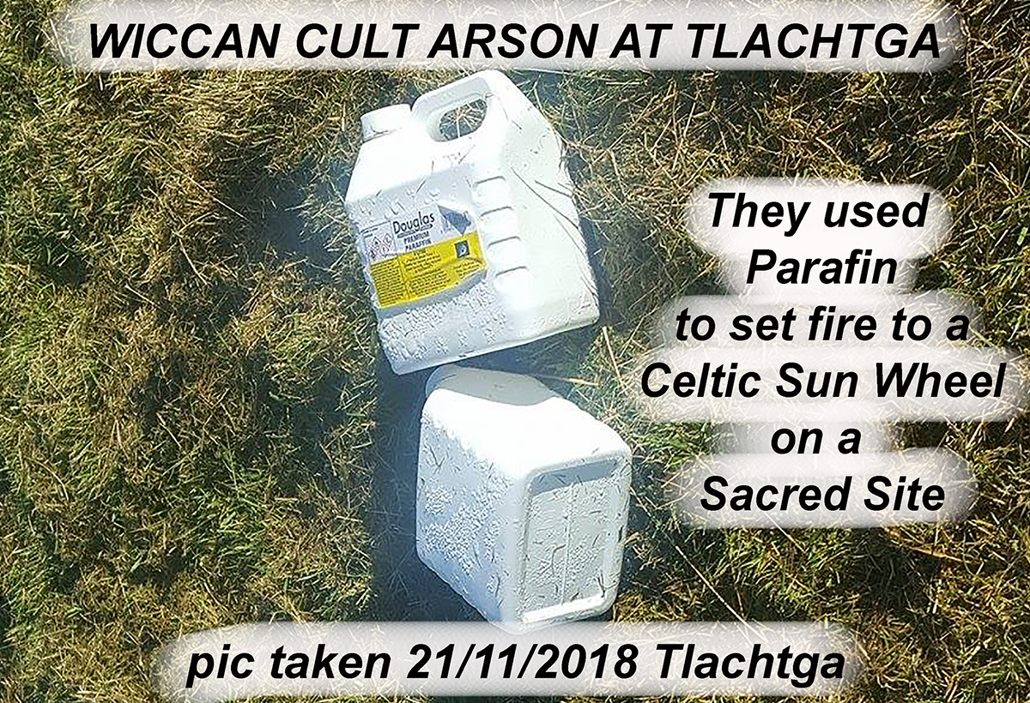

Who did this 'burning of the temple of the goddess Tlachtga'?

The answer is a cult of wiccan, obod and foi members and the tweedies (theatrical narcissistic primadonnas). They used grant aid (taxpayers money) provided by Failte Ireland organised by Cllr David Gilroy. This is the same cult that is blocked from having fires at the Equinox on Sliabh na Callighe and the same cult that burns paraffin dripping wicker Triple Spirals at Uisneach on Bealtine. Two key players at Tlachtga '18, Karen Ward and Gemma McGowan are shown in the picture below.

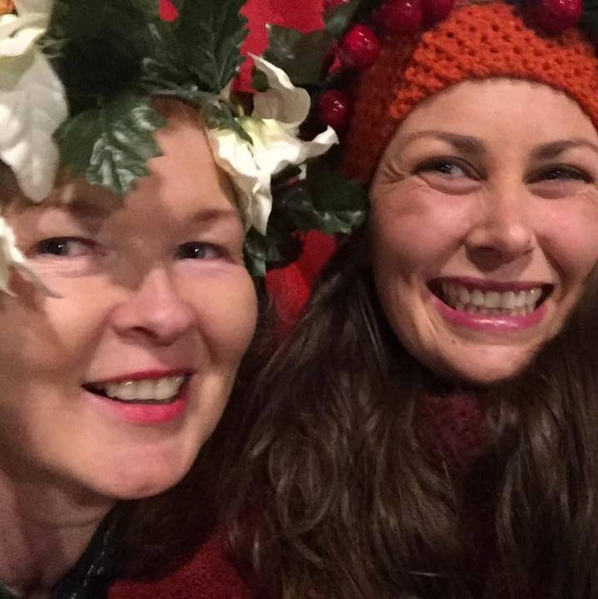

Who are these wiccans?

Wicca is a witchcraft based cult founded by an English charlatan named Gerald Gardner in the 1950s. It is a mass commercialized cult that continues to morph and evolve as it strives for social acceptance. Gerald Gardner claims initiation into a British witchcraft order, but there is no supporting evidence to back this up. Gardener got his knowledge from Aleister Crowley, occultist and freemason who founded the religion of Thelema based on the control magic system of Hebrew Cabala / Jewish mysticism. “Do what thou wilt shall be the whole of the Law”, as written in 1904 by Aleister Crowley can be seen as the source of the Wiccan Rede - “Eight words the Wiccan Rede fulfill, An it harm none do what ye will”. First published by Doreen Valiente in 1964 the wiccan rede (rule) can be seen as encouraging every wiccan to take personal responsibility for his or her actions.

Valiente was an archaeologist and author and is seen as the "Mother of Modern Witchcraft". By the mid-1950s, she was initiated as High Priestess of Gardener's coven. Valiente was a firm believer in Margret Murray's 'horned god religion' theory even after it was academically discredited. The Murrayite Witch-Cult theory presents the pagan religion of the horned god surviving the efforts of the church to extinguish it. Margret Murray's 'horned god religion' had a significant influence on Valiente and on wicca today even though it has been fully disproved as false, it is part of the nebulous foundation of wicca perhaps because it fits an undeclared need for a fantastic lineage that they can retro-fit!

The premeditated planned hurt and wrong done by the 'wiccan burning cult' on Tlachtga to indigenous peoples traditions and ancient temples demonstrates they do not even honour their own rede/rules. There is no ancient historical basis for wicca in England or Ireland and so they cannot have any ancient temples anywhere in the world. They do not have a declared 'leader' today but a pattern can be recognised as many wiccans will claim anything they perceive as a goddess / god pairing adopting it, calling it their own thereby fundamentally wiccanizing it. The 'wiccan burning cult' does not represent all wiccans. Senior wiccans in Ireland condemn the deliberate fire damage and multiple post holes dug in to the temple by Gemma McGowan and the 'wiccan burning cult' at Tlachtga on 31st Oct 2018. Gemma McGowan is an initiate wiccan and was the lead ‘celebrant’ at the burning of Tlachtga ‘18.

Who are the obods?

In 1954 Ross Nichols helped his friend Gerald Gardner (founder of wicca) to produce his first non-fiction work on Wicca – “Witchcraft Today”. Nichols was a member of the Ancient Order of Druids that was founded in 1781 in London as part of the Masonic Grand Lodge. The AOD modelled itself along the lines of Freemasonry and Christian Cabala. Nichols morphed from mason to wiccan to druid and in 1964 Ross Nichols founded obod and declared as chosen chief. During this seamless transformation by re-branding he also held ceremonies with the Robertson’s at the Fellowship of Isis in Ireland.

Obod's lineage emerged from Freemasonry and Christian Cabala which began in the desert philosophies of the Hebrews, Israelites; Jews and Samaritans. This is far far away from the green forests of the Celtic Homelands. Nichols, Gardener and Robertson happily stirred their cauldrons of magical illusion filled with ingredients taken from the English masonic version of the magical system of Hebrew Cabala / Jewish mysticism. All three developed their own eclectic pick and mix variation but all three have their practice based on the same Hebrew Cabala. They only added in bits of 'Celtic' later on... Philip Carr-Gomm, current obod chosen chief, having been groomed since he was 11 years old was initiated into obod by Ross Nichols. Carr-Gomm was holding ceremonies at the Fellowship of Isis during the late sixties and seventies. The next obod chief elect is Eimear Burke and she is based in Ireland and currently active with the Fellowship of Isis and the 'wiccan burning cult'.
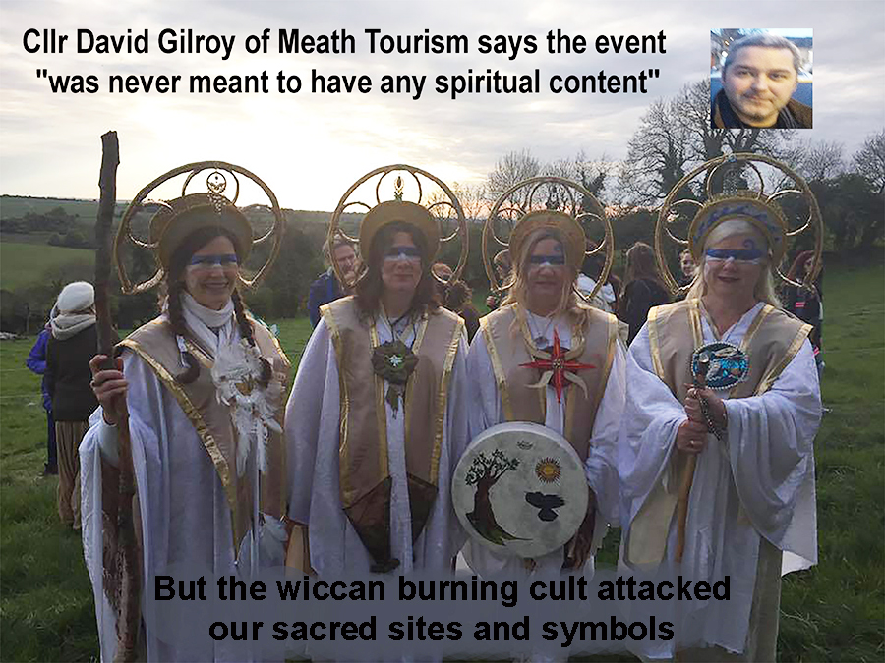

A deeper look at the lineage fraud perpetrated by obod takes us back to 1792, when Edward Williams (aka Iolo Morganwg, stone mason and freemason), claimed direct knowledge of the rites and customs of the ancient Druids. Iolo was an opium addict and a forger and the full nature and extent of his invention and deceit is simply incredible. He declared that his Glamorganshire Bards had an unbroken line of Bardic-Druidic tradition going back to the Ancient Druids. His local masonic lodge accepted without challenge all of Iolo's claims in the 1790's – but these days they 'neither confirm nor deny' online if Iolo was initiated or held membership...

Iolo's fraudulent works inspired wicca founder Gerald Gardner who fully believed in Iolo's "scholarship". Gerald Gardner inspired Ross Nichols who also incorporated Iolo's outrageous claims into his obod. Iolo is still presented as being a druid on obod websites despite the fact that the scholar G. J. Williams systematically demonstrated the extent of Iolo’s forgeries and fabrications in the 1950's long before obod was set up by Nichols. In Nora Chadwick's book THE DRUIDS published by the University of Wales Press in 1966 on page 13 the scholar tells us “there is no good historical evidence for the survival of druids into the historical period in Wales”. By inference she is possibly referencing Iolo's 'bad works of forgery'.

So they all know that Iolo lied. Obod continues to compound the profitable fraud because Iolo's “Druid's Prayer” is central to obod practice today. Iolo has been thoroughly exposed as a fake but many still follow him in the misguided belief that his forgeries can guide them to 'awareness'. Obod chief Carr-Gomm on his own website even says - “It’s all been made up. It’s all fake and pretend!” declaring “every spirituality is ‘made up’” and that “Christian scribes wrote down the Pagan stories and preserved them for us”. Is he oblivious to the well-known reality that the church scribes lied about everything that did not suit their purpose? Or is he trying to sell his books to the 'celtic christianity' market sector shepherding the strays into membership of his cult? Nichols, Carr-Gomm and Burke know all about Iolo's extensive forgeries. They have used Iolo's lineage claims to create a false foundation from which they pretend to be 'druids'. They are aware that the scholars G. J. Williams and Nora Chadwick prove Iolo's claims of druidic lineage to be fraudulent beyond doubt – yet the obod chiefs persist with their scam.

'Druidcraft' was developed by Philip Carr-Gomm as a practice embracing obod and wicca that dramatically increased obod membership. This was easy for him to do as both groups have been singing from the same hymn sheet since they were set up by two friends in the 1960’s. Obod is an initiatory order like wicca and freemasonry, it is not a church or religion. Its cult membership includes deluded monotheists, polytheists, pantheists, atheists, christians, buddhists, jews, wiccans, eclectic, eccentrics and pagans of various traditions.

The fraud being perpetrated by the lineage of obod chiefs exploits seekers because what they present as a 'druid path' begins by initiation into practices founded on Iolo's opium fantasies and forgeries mixed with freemasonry and desert philosophies. Such notions have nothing whatsoever to do with Celtic Druidism. There are genuine people in obod but all their chiefs have been dishonest with all seekers since the beginning.
No matter how many people believe a lie, it’s still a lie.
Who are FOI?

The Fellowship of Isis is a multi-religious, multi-cultural, multi-racial organisation dedicated to the Egyptian goddess Isis based in Clonegal Castle, Co Wexford. As such, it is not part of any Celtic tradition. The Egyptian goddess Isis had a cult following that was widespread throughout the Roman Empire. Olivia , Lawrence and Pamela Robertson created the Fellowship of Isis on the Vernal Equinox of 1976 in order to assist in reintroducing the religion of the Goddess to the world. Lawrence Robertson, a serving Anglican Minister, can bestow knighthood through his Baronial Court since 1979, a distinctly non Celtic practice. Olivia died on 14 Nov 2013.

On the FOI website Olivia says: “my cousin Robert Graves wrote about the Goddess long before Isis called us”. Robert Grave's book 'The White Goddess' (published in 1966) is a combination of poor philology, inadequate texts and out-of-date archaeology that has misled many innocent readers with his eloquent but deceptive statements about a nebulous goddess in early European literature on which he was no authority. Scholarly criticism shows Grave's book to be “deeply flawed”, “lacking accuracy” and is “not scholarship”. On page 125 and 126 of 'The White Goddess' he even depicts Crom, Ireland's ancient male fertility Dragon as the Greek strongman Herakles (Hercules) who actually strangled serpents! It is in 'The White Goddess' that you will find all those fantasies which posit (pre)historic matriarchies from which many confused angry cults draw their inspiration today. Another fraud or fake/fantasy history at the foundation of a cult in the same era as wicca and obod! The drummer in the pic below is Deirdre Wadding of FOI.

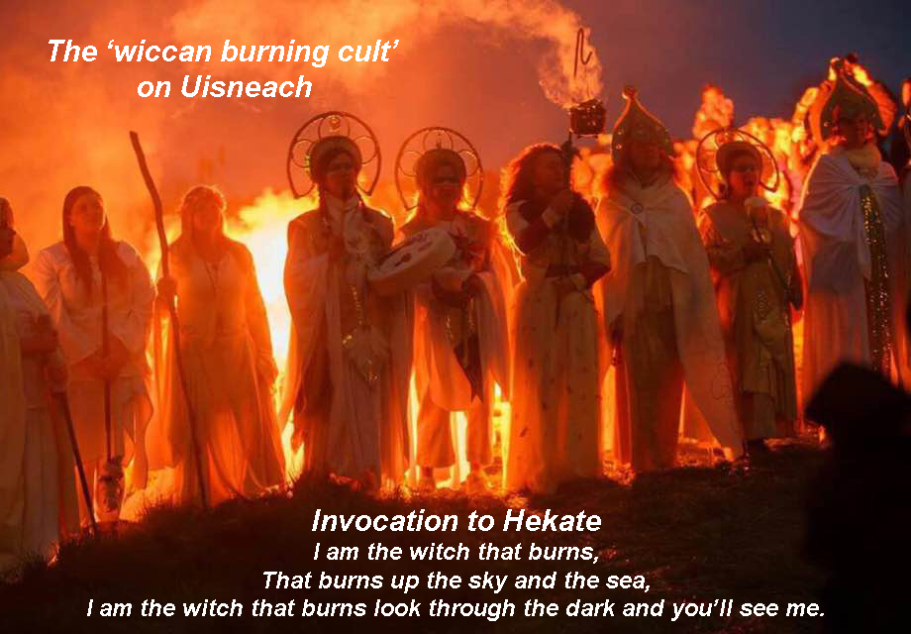

The FOI and Ross Nichols of obod did 'druid rituals' inside the ruins of the 14th century FOI abbey in 1963. Carr-Gomm also did 'druid rituals' with the FOI during the late sixties and seventies. Eimear Burke (obod's next chief) is involved in various sub groups in FOI and is also an active member of the 'wiccan burning cult' and features in Issue 1 of the FOI newsletter.

Olivia Robertson knew Ross Nichols, Carr Gomm and Burke and they all did 'druid ritual' with her at her castle. Not only was Olivia fooled by 'The White Goddess' and the forgeries of obod's Iolo but as a young girl, she and Lawerence would also “visit an old Druid hermit called Daniel Fox who lived on the banks of the Slaney”. This is one part of her version of Iolo's 'unbroken line of Bardic-Druidic tradition going back to the Ancient Druids'...

In the FOI Isian News Lughnasa 2018 Issue 01 page 34 it says of her old Druid hermit - “He had total clairvoyance and could see people from ages past. He spoke to Olivia and Derry of the old ways and initiated Olivia as a Druid by asking her to drink from an ancient well of which he was the guardian.” Olivia lived in an imperial plantation castle, was initiated when only a child as a ‘druid’ by the last Irish Druid (lol), she was the sister of a serving Anglican Minister who gives knighthoods and they all worshipped an Egyptian Goddess called Isis! The 'unbroken lineage' needs of freemasonry, Iolo, obod, wicca and foi has all these groups sharing heritage fraud at the centre of their their foundations. Their diluted and mutated pick and mix eclectic syncretism is founded on forgery and wishful thinking and is more than just "deeply flawed".

To me as a commentator I see their fulfilling of their lineage needs with fake heritage as declaring that they do not stand in their own truth and therefore they do not and cannot have true connection to the higher awareness of any tradition.

The Fellowship of Isis has a Code of Ethics on its website that says - “Sacrilegious desecration of the spiritual religion of the Goddess constitutes legitimate grounds for automatic expulsion from the FOI.” But despite this Code of Ethics senior members participated in the 'wiccan burning cult' hate crime / fire damage / symbol burning / temple digging on the Earth Goddess's most sacred temple on Tlachtga '18. Perhaps the their 'Code of Ethics' is just another tick box exercise like the wiccan rede or maybe it is only meant for lower members.

In the foi newsletter Issue 2 there are only a few words written in the report about Samhain 2018 –
“One of our members had spent some time prior to this on the Hill of Tlachtga celebrating the Samhain festival there, she spoke with great admiration of this celebration and shared a chant created by her good friend, which we all delightfully sang along to. Once again it was wonderful to experience the weaving of all the different threads in the celebration joining together to create such synergy and healing for all concerned.”

This cute report was about the ‘wiccan burning cult’s’ attack in 2018 on the indigenous people and their pilgrimage traditions to the temple of the Goddess Tlachtga. They say “one of our members” perhaps attempting to protect the core group from prosecution, while at the same time they do not mention the fire damage etc to the Temple of the Goddess Tlachtga. Their report does not name Deirdre Wadding or mention her involvement in the burning of an ancient sun symbol, or the fire damage to the temple or declare how many postholes were dug into the temple nor does the report mention that it was a theatrical event planned to be without spiritual content, or that there was no community involvement or that the Keeper of the Hill stayed away.

A senior foi member oversaw the burning of Tlachtga '18 with the tweedies and players from obod and wicca - what a luvly fantasy for a Disney movie! But it is not Celtic - is a fraudulent cult scam. Lies upon lies perpetrating compound fraud that all senior FOI members are fully aware of is their policy. This is all very unfair to true seekers but can be seen as a common denominator in obod, wicca and foi.

I reckon that having personally known Olivia herself, that if she were still alive, she would have rushed forward to stop the ‘wiccan burning cult’ from burning the Temple of the Goddess Tlachtga!

Who are the 'tweedies'?

Two 'theatrical narcissistic primadonnas' actors, individuals who have ingratiated themselves into the obod/wicca/foi circles in Ireland and England over the last few years. Commonly known as the 'tweedies' - Karen Ward and John Cantwell are the leading fame and glory seekers of this 'wiccan burning cult'. At Brú na Boinne after midwinter sunrise 2018 the tweedies appeared just in time for the rte tv coverage. This 'appearance' was separate to and after the huge group circle ceremony but was made out as part of the ceremony as in a ‘Salafia media style tv policy’.

It is unknown at this stage if the tweedies are responsible for the 'Ziegfeld Follies' style headdresses or the 'xmass lights on the body' worn at the 'wiccan burning cult' attacks on Tlachtga and on Uisneach but it is highly likely. Those elaborate theatrical headdresses worn with xmas lights on the bodies of the performers with scary face masks; all generate gaudy glamour while hiding their faces but the fools put videos online so everyone can measure just how stupid they really are. Karen Ward annually brings a women's group on pilgrimage but in a misandric show of man hatred – she refused an offer by a group of respectful men to wash the feet of the female pilgrims at Slane.

Pic below with xmas lights; Tlachtga '18 - Deirdre Wadding and Karen Ward.

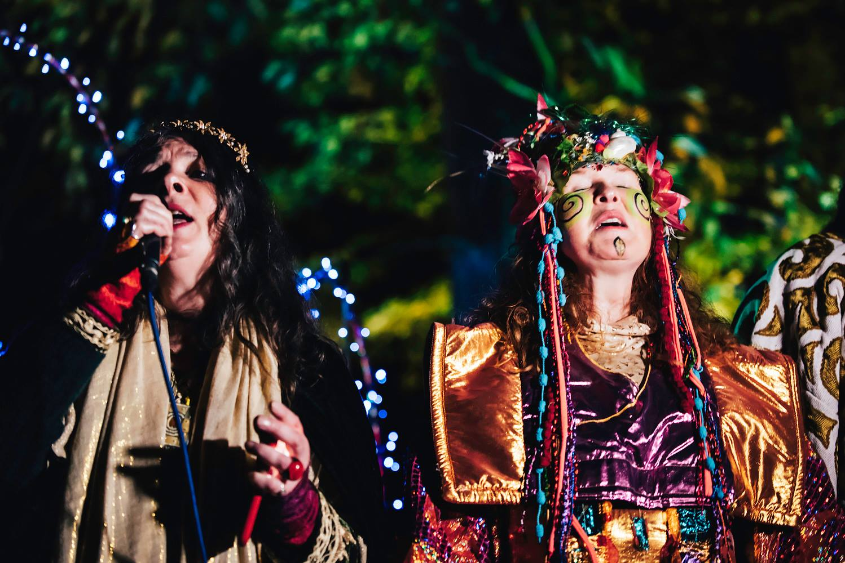

At Uisneach in 2018 this 'wiccan burning cult' by its actions declared itself as overtly misandric when they prevented men from accessing the Catstone and by holding a 'ring-pass-not' women-only circle enclosing the main ceremony! The all white gown silly headdress circle of women that excluded men at Uisneach is part of their 'magic spell' that fooled many. Their egg shaped circle of militant women excluding men from being near the central fire was a 'conception' spell performed to empower a few ego's to fame and glory. It was designed to propel them onto to even greater 'wiccan burning cult' events such as at Tlachtga ‘18. Their 'gaudy glamour' is just as transparent as the Emperor's New Clothes but when seen with the 'Ziegfeld Follies' style headdresses it is obvious that their planned future stage for personal adoration / profit is the tv screen. Simply put, their plan looks like commercial tv glory for the tweedies using the wiccans, obods and foi as free willing extras. Not Celtic in any way.

The 'wiccan burning cult' of wiccan, obod, foi and the tweedies are simply not Celtic nor are they connected in any way to any native indigenous spiritual traditions. Instead the cult displaced native practices and they dug and burned our most holy sacred site. Someone fooled them all by handing out roles, designing costumes and guiding stage management, but the tweedie wiccans got centre stage with taxpayers money, the obods continue to sneak their sugar coated freemason practice into greater acceptance, the foi pursued their 'goddess good' fantasy too even though they did actual damage to a goddess temple. An all this was organised under public money from Cllr Gilroy who said - “the event was only ever meant to be theatrical”.

So, who fooled who? They only fooled each other with multiple sub-plots but they did not fool the 'Friends of Tlachtga©' local group or the Celtic Druid Temple who can easily see the dark intention in their performances.

The wiccan fire damage to our ancient temples recalls the desecration by the roman church, the vikings, the normans and by cromwell who all attacked our indigenous temples with fire! Let us not forget the Masonic Lodge that presented as the ‘British Israelites’ in the early 1900’s digging up Tara in a frantic search for a super weapon called ‘The Ark of the Covenant’. WB Yeats confronted that lightly disguised masonic cult until they stopped. Today’s ‘wiccan burning cult’ must not be allowed to continue with their hate crimes of grant aided vandalism by fire at Ireland’s sacred sites.

To put their actions in a wider religious context -

They did not burn Catholic Crosses at Churches

They did not burn Stars of David at Synagogues

They did not burn Crescent Moons at Mosques

They did not burn Squares and Dividers at Masonic Lodges
They did burn one of our oldest sacred sun symbols as they burned the ground inside an ancient temple of Celtic Ireland, they did dig holes for their flags and props and they even gave a fully narcissistic after taste when they left two paraffin cans and some heavy black plastic as rubbish marking their take-over claim!

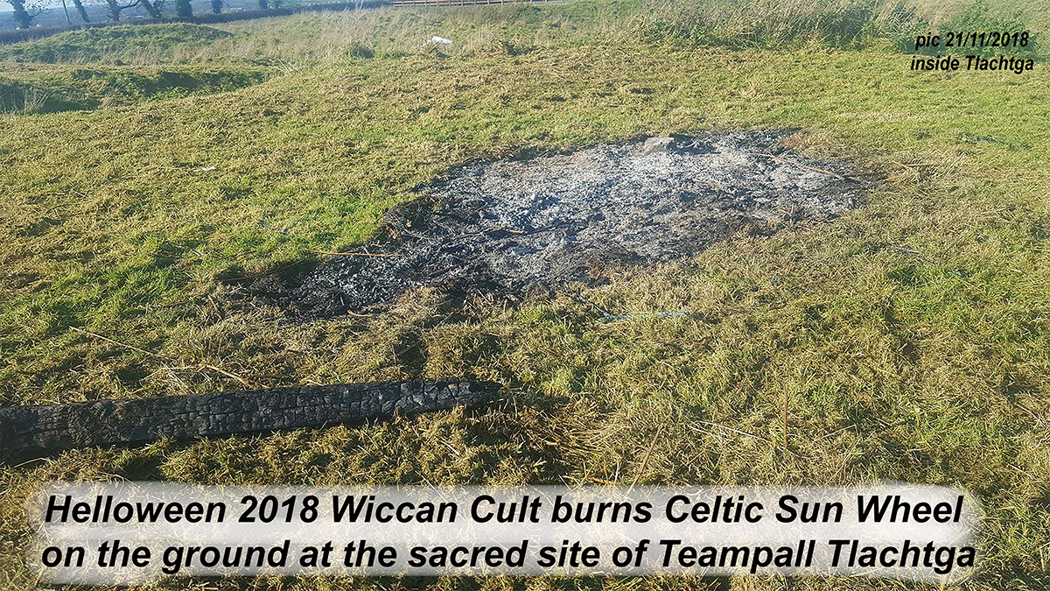

Colonial cultural misappropriation.

What is happening is incremental cultural misappropriation. This is colonial hijacking by a mutated but disguised English freemason tradition of an Irish indigenous practice at Irish indigenous temples. Their cultural mis-appropriation is theft analogous to the seizure of land and artefacts that does not acknowledge the feelings of the natives experiencing theft and displacement. The 'wiccan burning cult' is in the process of using taxpayers money to acquire full or partial control over Ireland's ancient temples at the times of locals’ celebrations, occupying them with theatrical performances for tv, and exploiting them economically for vulgar tourism purposes while pushing the indigenous peoples pilgrimage traditions away.

The cultural misappropriation practices of colonialism at Ireland's ancient temples by these wiccans includes - 1. They take. 2. They never ask or borrow. 3. They never return the thing they took. 4. They never say thank you. 5. They purposely exclude the locals and their traditions. 5. They do it all for profit either financial or egotistical or both. 6. They take indigenous practice and do it in a completely different context where it does not fit. 7. They take local rituals, pilgrimages, or stories and pretend they are theirs. 8. They take the local ritual and the sacred site and then exclude the locals from it. 9. They are doing someone else’s practice and pretending to be authorised by the people whose practice it is, thereby claiming a fake identity as an indigenous practitioner. 10. The cult misrepresents the indigenous practice of the locals and makes their real struggles invisible.

Their deliberate misappropriation involves harming two groups through misrepresentation and disrespect of our culture, tradition and beliefs. Because the cult was grant aided their misappropriation is harder to counter as it appears that they have state support to burn our ancient symbols and our ancient temples.

The “cultural heritage” at Tlachtga combines elements that are common to locals because they are culturally meaningful, connected to shared memory and linked to collective identity. The “tangible heritage” at Tlachtga is access to the temple itself on those special days and nights. The “intangible heritage” is the cultural expressions, traditional practices and knowledge including stories, ceremonies and celebration of the locals and not the theatrical gaudy glamour of a disguised English freemasonic wiccan burning cult.

Cllr David Gilroy is Chairman of Boyne Valley Tourism. The 'wiccan burning cult' includes obod, wicca, the tweddies and foi as well as Healers Spiral graduates, Moon Mná facilitators and Sli an Chroi. Their black magic hate crime on Tlachtga at Halloween ’18 was led by Gemma McGowan, Karen Ward, Patsy Preston, retired Cllr Deirdre Wadding and John Cantwell. Their cult has over 200 members and the active leaders are named above.

I do not attack these people or any organisation by loudly blowing a whistle, sounding the alarm or by going public online about their attack on our heritage or by telling the truth about their lineage.
By informing the Gardaí who are pursuing a criminal damage to a national monument case because of what the cult did on Halloween ’18, I am not attacking the cult leaders either. I am exposing what they did so they will never do it again. It is my intention that no minister or county councillor or tourism chief will grant aid the ‘wiccan burning cult’ with taxpayers money ever again.

But how do we the people, stop the ‘wicca burning cult’?

Maybe this should read – “what can I do?” You can join us on Tara for this Summer Solstice from Friday through to Sunday and become a ‘Protector of Tara’. By extension this means you will be part of a 32 county team that protects all of the ancient sacred temples in Ireland. You do not need to be a druid, there is no initiation, xmas lights or fantastic hat / mask nor membership fee or tv cameras – you just get involved as a Protector of Tara by being willing to say NO to any person/s or cult that tries to attack our heritage with cultural insults, by fire or by digging inside any of our ancient temples.

The key words when reporting any attack on our sacred temples are – ‘criminal damage to a national monument’ because this activates the Gardaí to investigate. If you can say “NO criminal damage to our national monuments” to the wiccan burning cult then they will quietly fade back into their shadows afraid of huge fines and jail time… See Note 2.

This report was written by Con Connor, Ard Druí with the Celtic Druid Temple. It has the full support of the Chairperson of CDT and the Tribann of Órd na Druí, and from the Guardians and Council of the European based International Celtic Druid Alliance, the “Keeper of the Hill” of Tlachtga and the Friends of Tlachtga.

Real truth stands proud as fake claims fade.
/|\ Con Connor. 09/04/2019
info@celticdruidtemple@gmail.com

Note 1
from https://www.archaeology.ie/monument-protection
Any notification of works at or in relation to a Recorded or Registered Monument should be given using this form - Ministerial Notification - Works at/near Monument - and forwarded to nationalmonuments@chg.gov.ie marked "Notification under the National Monuments Acts 1930-2004".
Protection which applies to National Monuments
For national monuments in the ownership or guardianship of the Minister or a Local Authority or which are subject to a preservation order or temporary preservation order, the prior written consent of the Minister is required for any works at or in proximity to the monument. Lists of national monuments in the Minister’s ownership or guardianship (by county) can be accessed here. A list is also available of national monuments subject to Preservation Orders. It should be noted that these lists may not be exhaustive and if you have any doubt as to the status of a particular monument, you should contact the National Monuments Service. For a list of national monuments in the ownership of individual local authorities please contact the relevant local authority.
Applications for Ministerial Consent should be made using this form - NMS 5-06 Consent Application Form 149KB and returned to:
The Director
National Monuments Service
Department of Culture, Heritage and the Gaeltacht
Custom House
Dublin 1
Full details of location, ownership and works proposed should be provided. Please see publications for additional advice. Breach of these requirements is an offence. It is also an offence under the National Monuments Acts to dig or excavate anywhere for the purpose of uncovering archaeological features without or otherwise than in accordance with a licence issued by the Minister for Culture, Heritage and the Gaeltacht.

Note 2 - fine not exceeding €10,000,000 or, at the discretion of the Court, to imprisonment for a term not exceeding 5 years or to both.
Enacted state law protecting National Monuments - http://www.irishstatutebook.ie/eli/2004/act/22/section/5/enacted/en/html

